UnitedHealth Group
ATDD FRAMEWORK
Manual Document
Villuri, Diwakar

Contents:
ATDD: Acceptance Test Driven Development 3
Introduction: 3
ATDD Framework Architecture: 3
ATDD Work Process: 4
Prerequisite Information: 5
Framework Setup - 5
Java Configuration: 5
Start Eclipse : 6
Installing Maven Plugin in Eclipse: 6
Check you have Maven plugin in eclipse: 6
Configure Eclipse with Selenium WebDriver: 8
Launch the Eclipse IDE & Create a Workspace: 8
Add External Jars to Java build path: 13
Install Cucumber Eclipse Plugin: 16
Cucumber Eclipse Plugin : 16
Steps to follow: 16
Extend Reports – Advance Reporting: 17
How to Create Cucumber Feature File 17
How to Create Step Definition File 19
Cucumber Options 21
How to use Cucumber Options? 21
Cucumber Options are used to set some specific properties for the Cucumber test. 21
21
Use of Glue: Cucumber to locate the Step Definition file. 22
POM: Page Object Model 22
✓ Page Object Model: 22
Github: 23
Jenkins Integration: 25
Reports: 28
Cucumber Reports: 28
Using with cucumber plug in generating the reports in html and Json format results. 28
Advanced Extent Reports: 28
Extent Report View: Using extent report to generate the html clear GUI report will generate. 28
Common Failure Solvation 29

ATDD: Acceptance Test Driven Development
Introduction: ATDD is a collaborative practice between business customers, developers, and testers in creating Gherkinized User Story Acceptance Criterion which are then automated using frameworks. ATDD Mainly involves team members with different perspectives (customer, development, testing) collaborating to write acceptance tests in advance of implementing the corresponding functionality.

ATDD Framework Architecture:
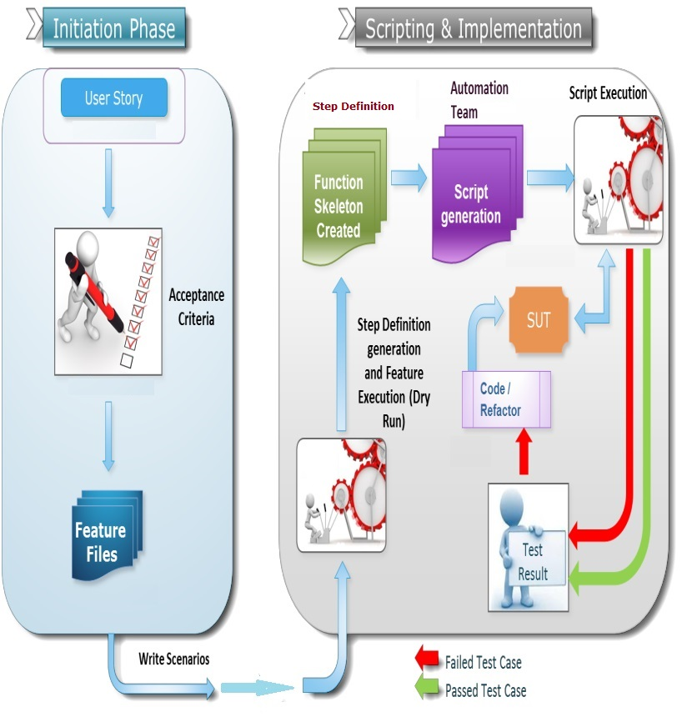

ATDD Work Process:
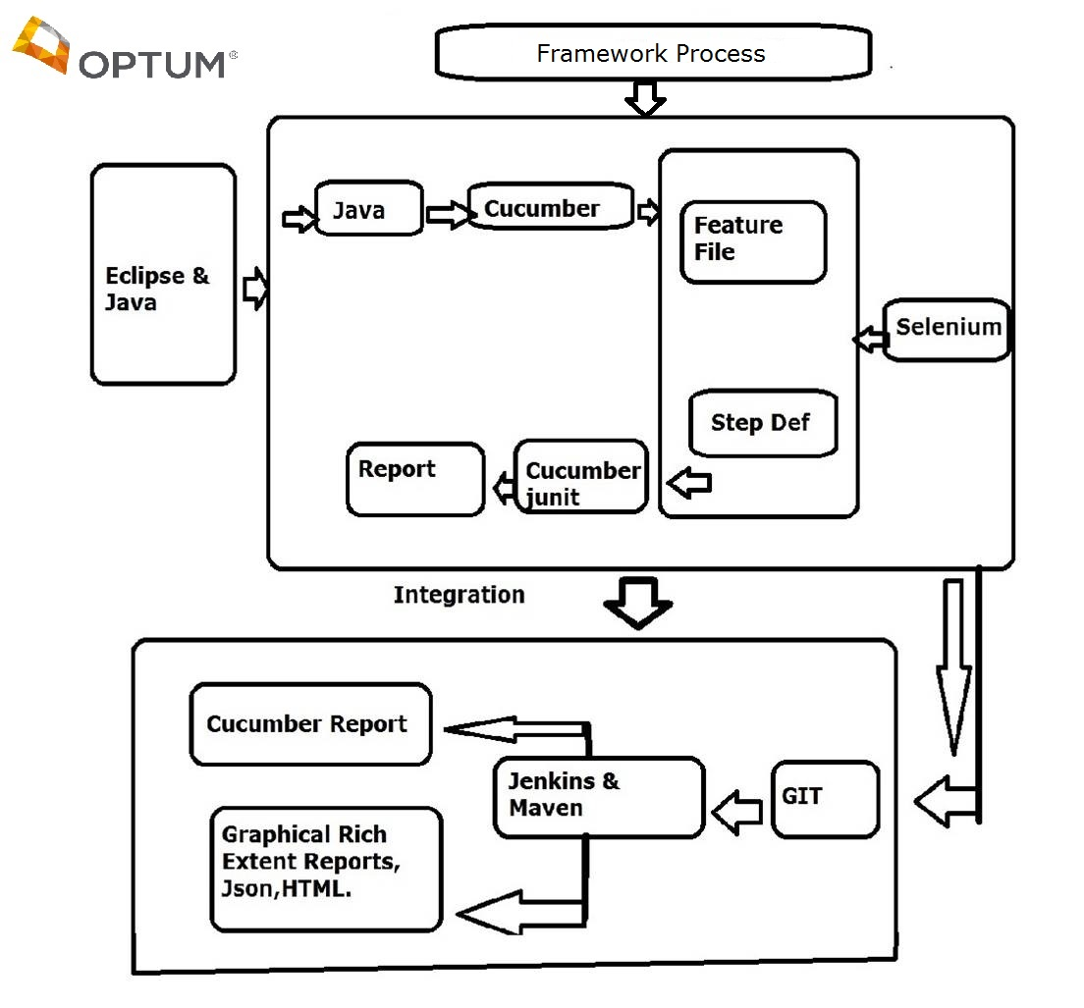

Prerequisite Information:
- Java
- Eclipse/Jboss – IDE
- Apache Maven – Build Tool
- Selenium – Automation Tool
- Cucumber – Execution Tool
- Extend Reports – Advance Reporting
- Git – Version Control
- Jenkins – Integration Tool

Framework Setup -

Java Configuration:
- Go to: C:\Program Files\Java
- Check you have “jdk1.8.0_51” or other version.
- Go to command prompt and type “java –version”
- If installation is correct you will get the version No and details.
- If you not found shown error so that you not installed java in you system properly.

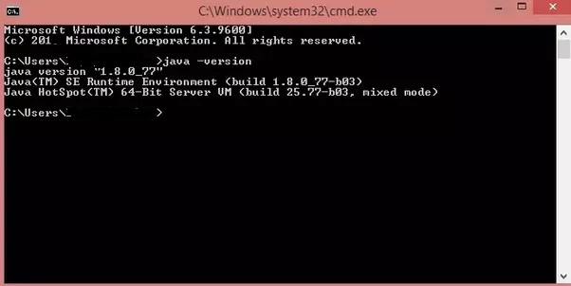

Start Eclipse :
- Download Eclipse for Java Developers, extract and save it in any drive.
- It is totally free. You can run ‘eclipse.exe’ directly so you do not need to install Eclipse in your system.
- After successful Installation you can able to view this page below.

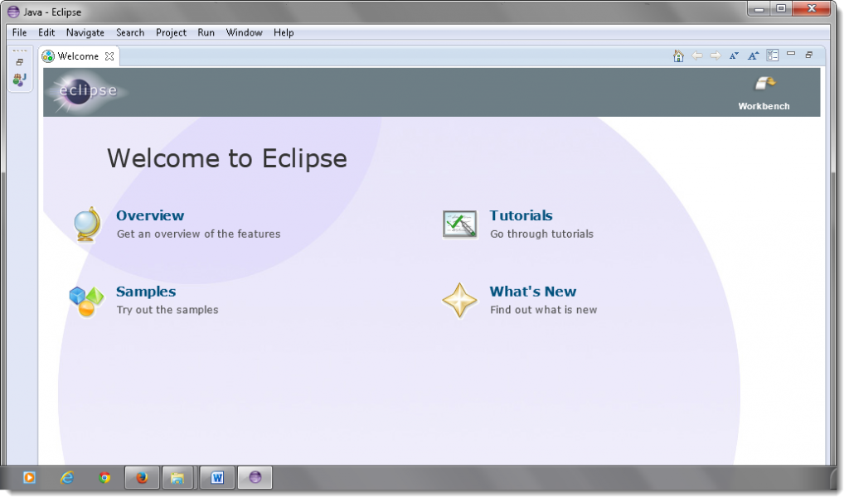

Installing Maven Plugin in Eclipse:
- Open your Eclipse IDE and click Help -> Search for Maven
- On the opened pop-up, click on the install and add a plugin in your eclipse.

Check you have Maven plugin in eclipse:
- Go to File-> New -> Others
- Scroll and verify you can find “Maven” in the ‘Select a wizard’ window.
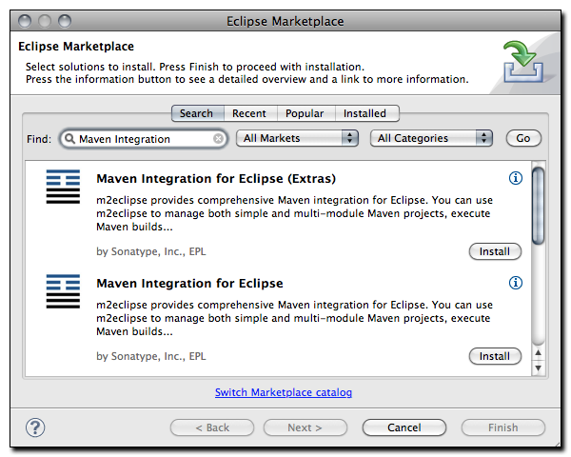

Configure Eclipse with Selenium WebDriver:
- Launch the Eclipse IDE & Create a Workspace
- Create a new Project
- Create a new Package
- Create a new Class
- Add External libraries to the project

Launch the Eclipse IDE & Create a Workspace:

Double click on ‘eclipse.exe‘ to start eclipse.
First time when you start eclipse, it will ask you to select your workspace where your work will be stored as shown in below image.
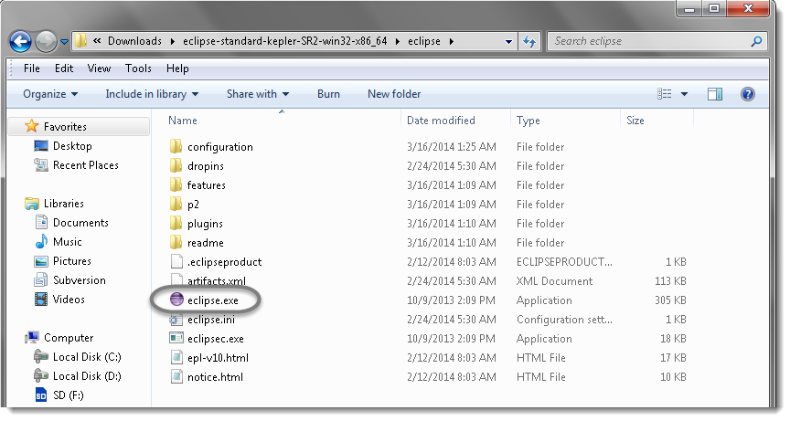
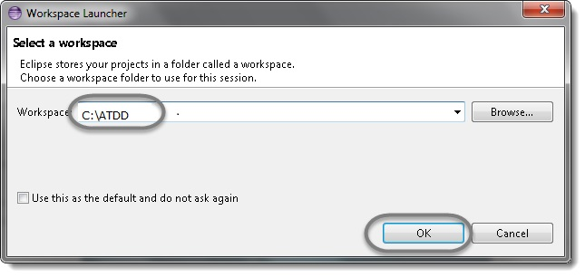

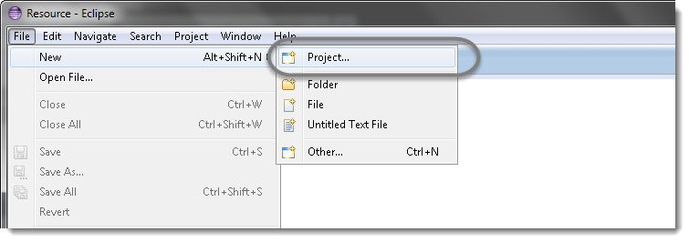

Select Maven Project if you not found Install plugin in Eclipse market shown above.

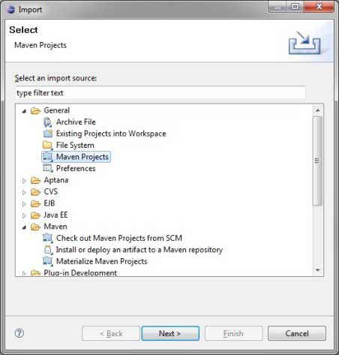
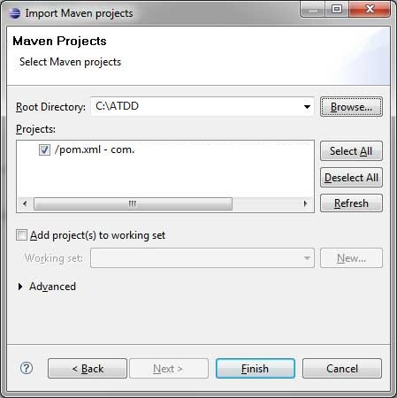
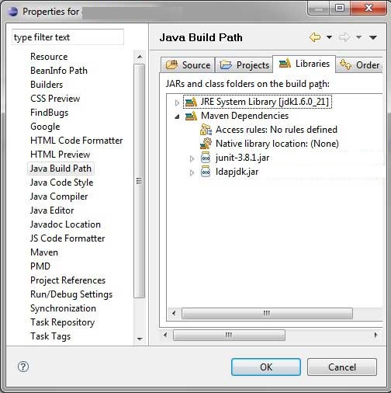

Add External Jars to Java build path:
- Right click on Project ‘Project‘ > Select Properties > Java build path.
- Then navigate to Libraries tab and click Add External JARs.
- Follow below images step by step.

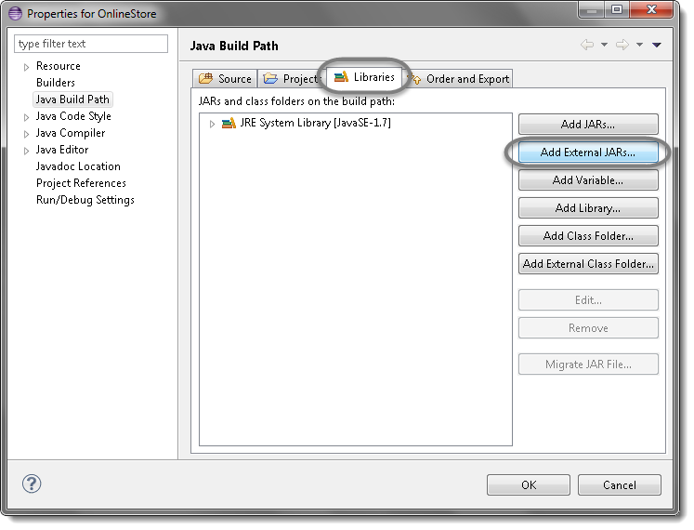

- Click On Add External JARs….
- Add Selenium Java jar, you may add the source file too.

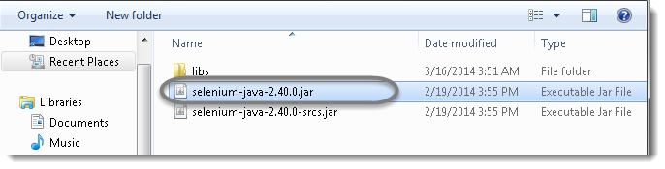

Add all the jars from the libs folder as well.
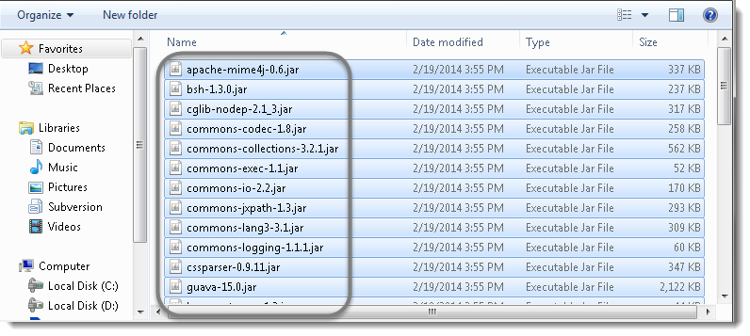
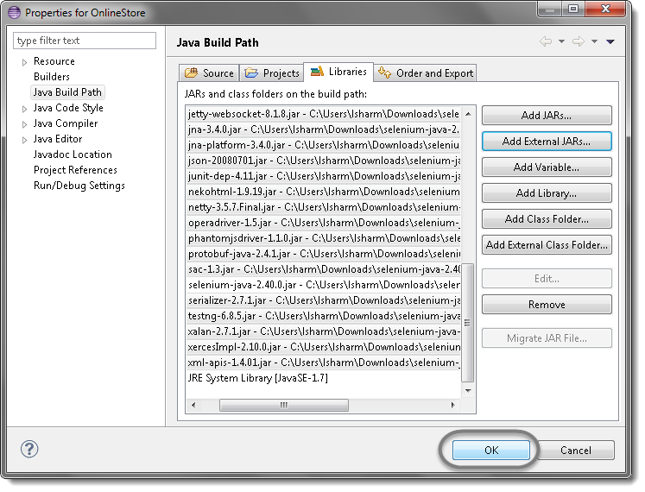

Install Cucumber Eclipse Plugin:
Cucumber Eclipse Plugin :Helps eclipse to understand the basic Gherkin syntax and it works like a syntax highlighter. It highlights all the main syntax in the feature file which makes it more readable and clear.

Steps to follow:
- Launch the Eclipse IDE and from Help menu, click “Install New Software”.

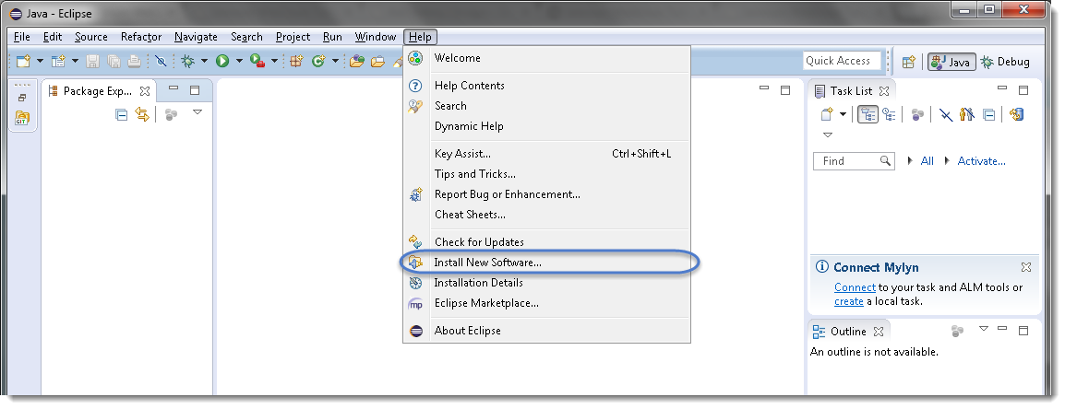

Extend Reports – Advance Reporting:

Add the dependency to Pom file

<dependency>
<groupId>com.relevantcodes</groupId>
<artifactId>extentreports</artifactId>
<version>2.41.1</version>
</dependency>

How to Create Cucumber Feature File

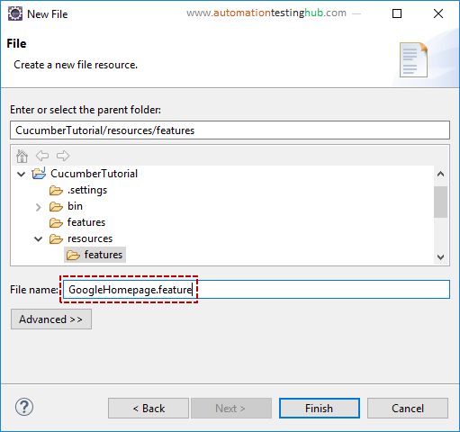

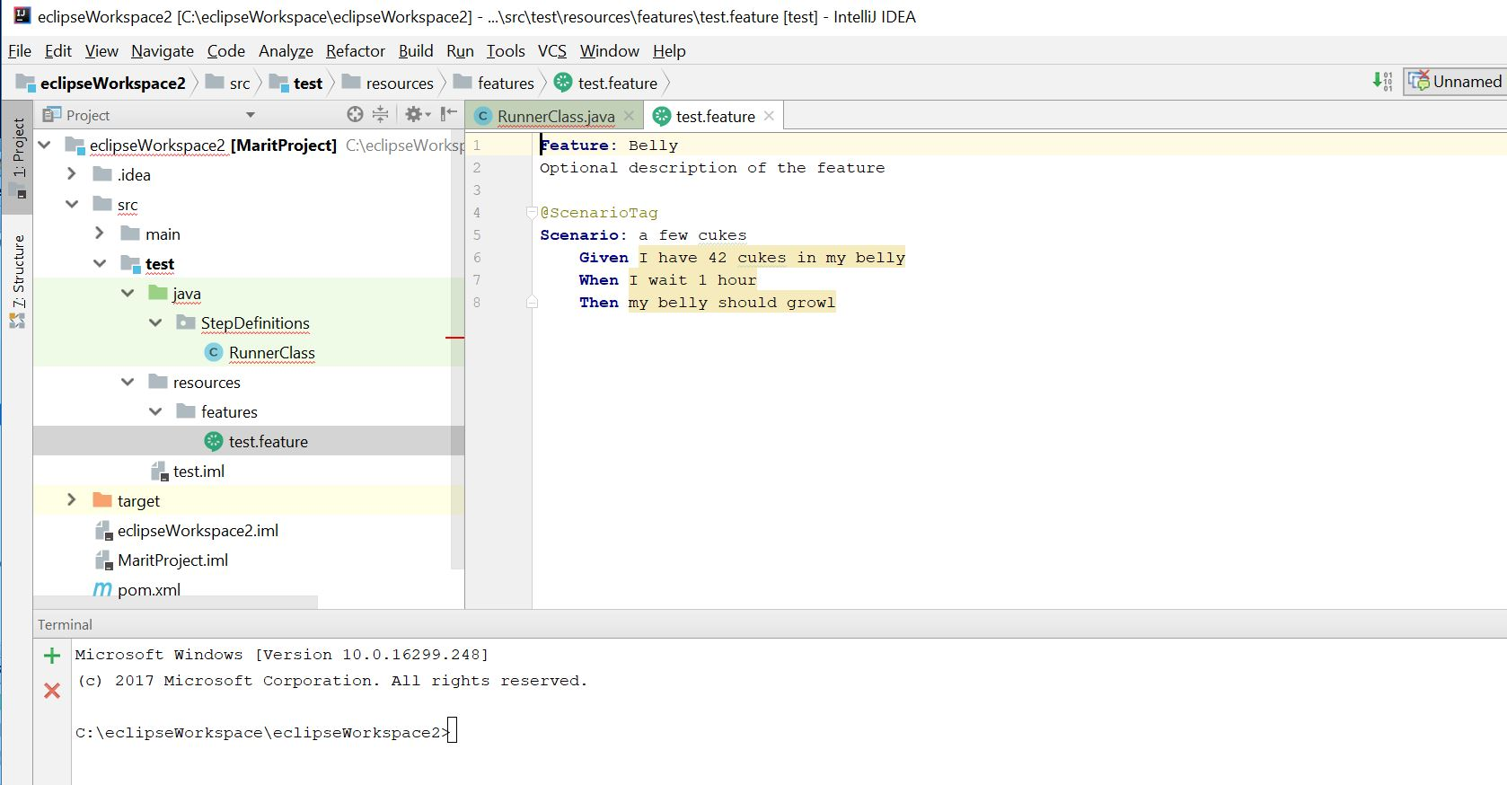

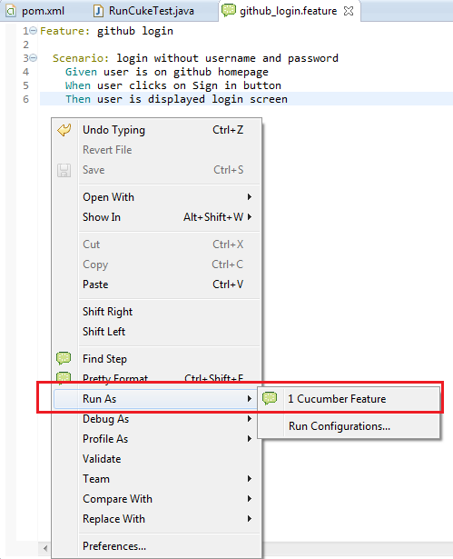

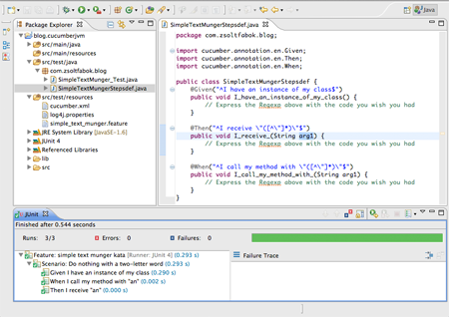

How to Create Step Definition File

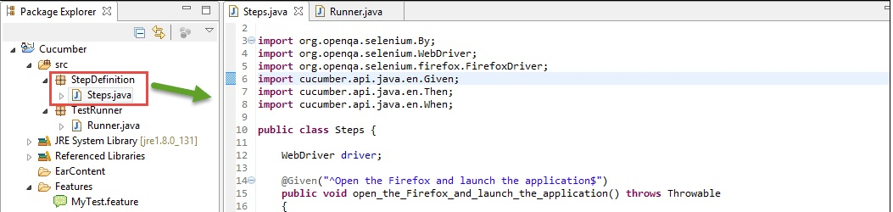

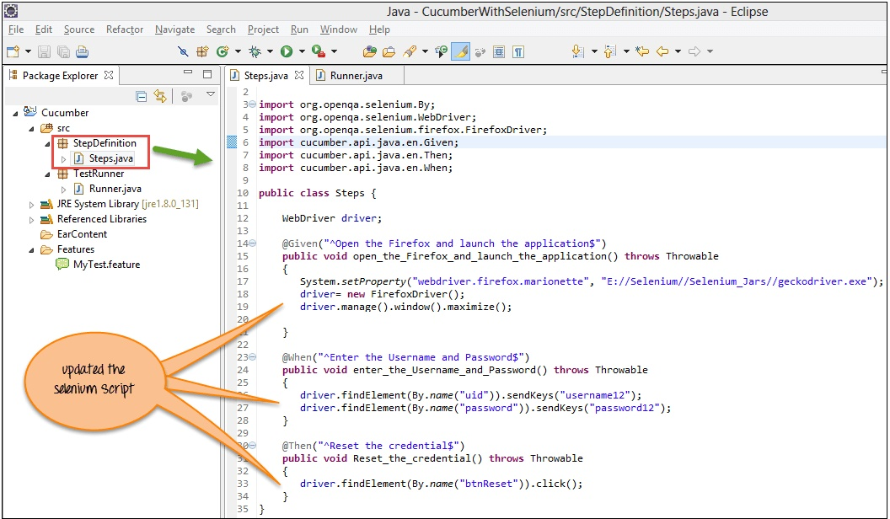

Cucumber Options

How to use Cucumber Options?

Cucumber Options are used to set some specific properties for the Cucumber test.

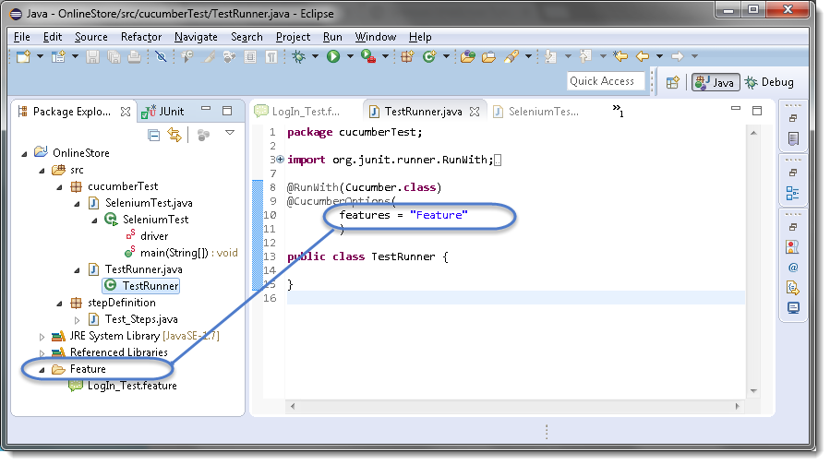

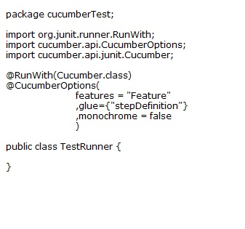

Use of Glue: Cucumber to locate the Step Definition file.

POM: Page Object Model
- Page Object Model: Page Object Model is a design pattern to create Object Repository for web UI elements.
- This Page class will find the Web Elements of that web page and also contains Page methods which perform operations on those Web Elements.

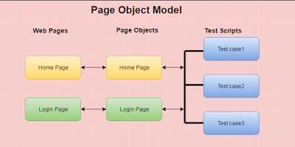

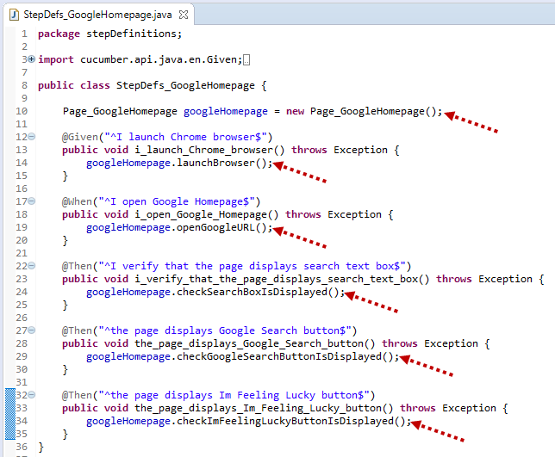

Github:
Git is used to store the source code for a project and track the complete history of all changes to that code.

- Create a Repository
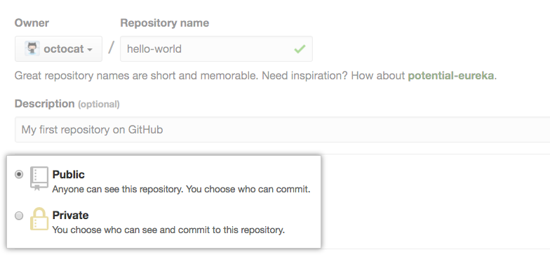

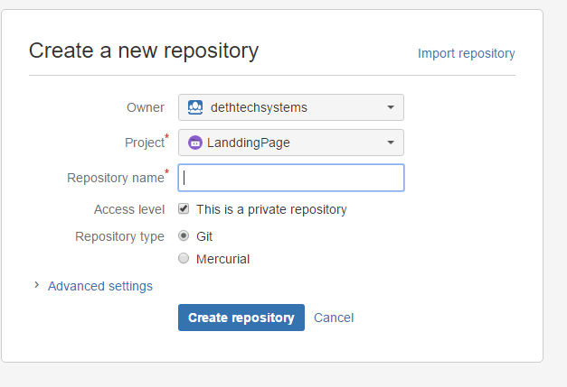

- Eclipse to Git
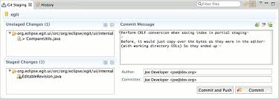
- Drag and drop files
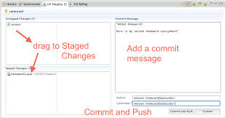

- Commit And Push
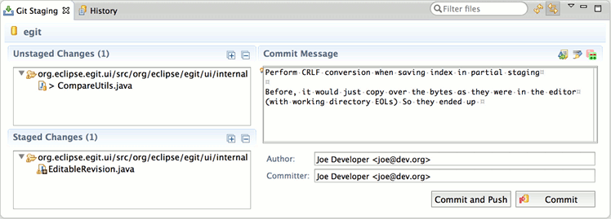
- Check the Repository URL. You can able to see all your project files.

Jenkins Integration:
- Configure a Jenkins job to use your repository.
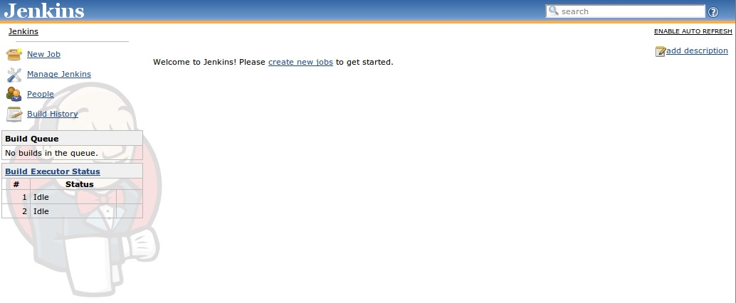
- Click on Configure System
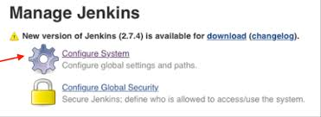
- Enter Git Credentials.
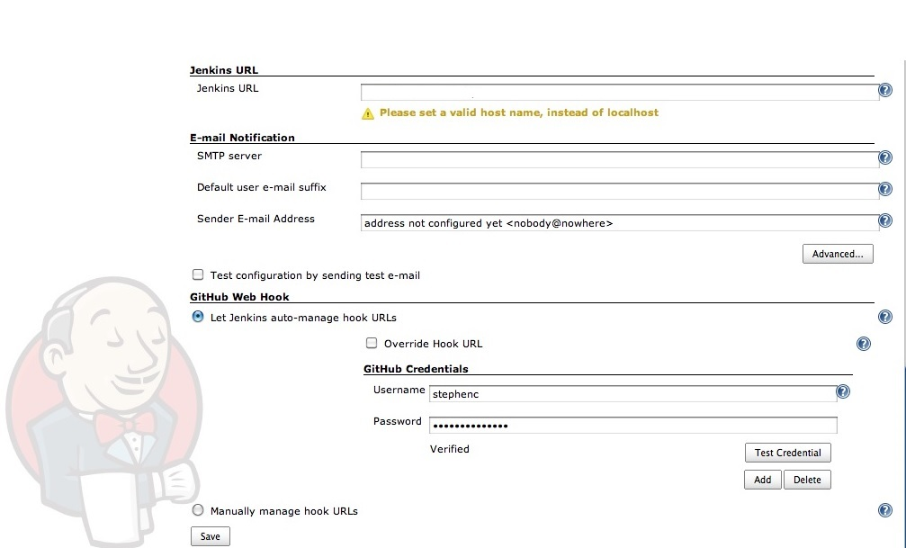

- Add Git Repository in URL path.
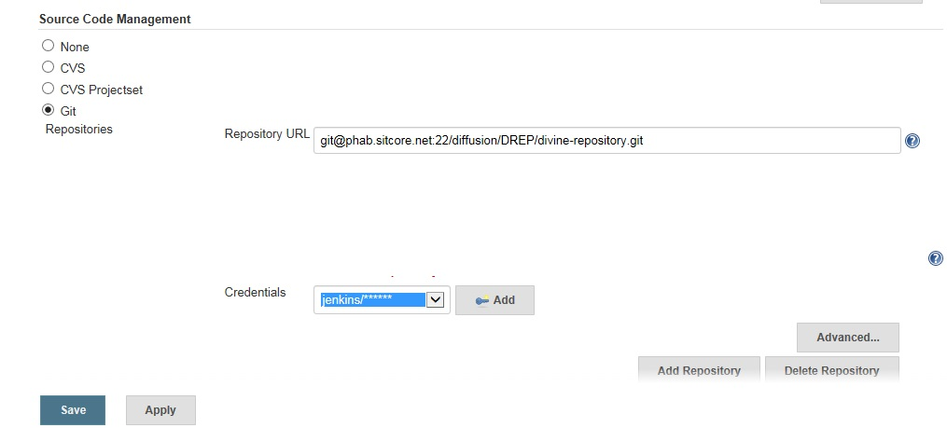

- Click on Build Now.

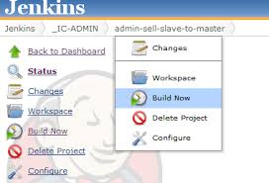

- You can able to view process,.
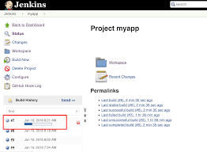

- Click on console output

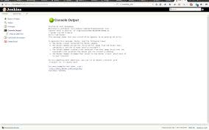
Reports: Results Generate in HTML, Json Format.

Cucumber Reports:

Using with cucumber plug in generating the reports in html and Json format results.

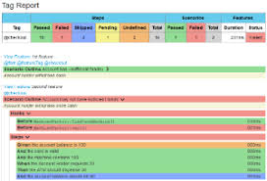

Advanced Extent Reports:

Extent Report View: Using extent report to generate the html clear GUI report will generate.

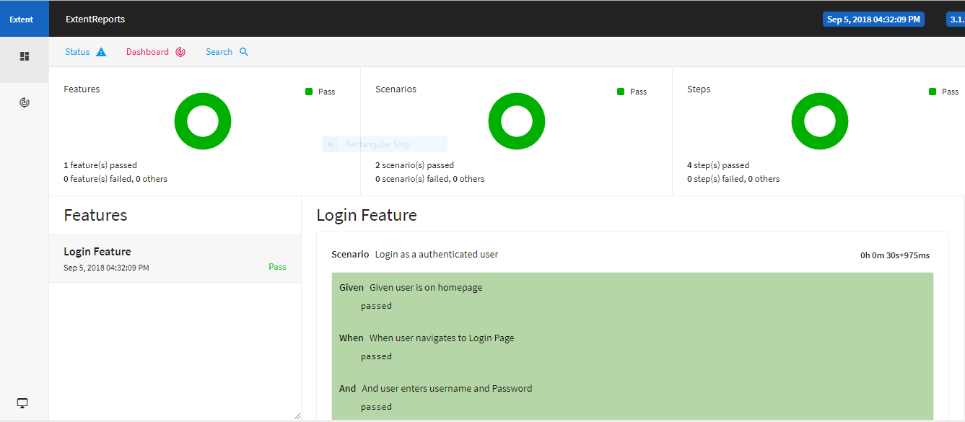
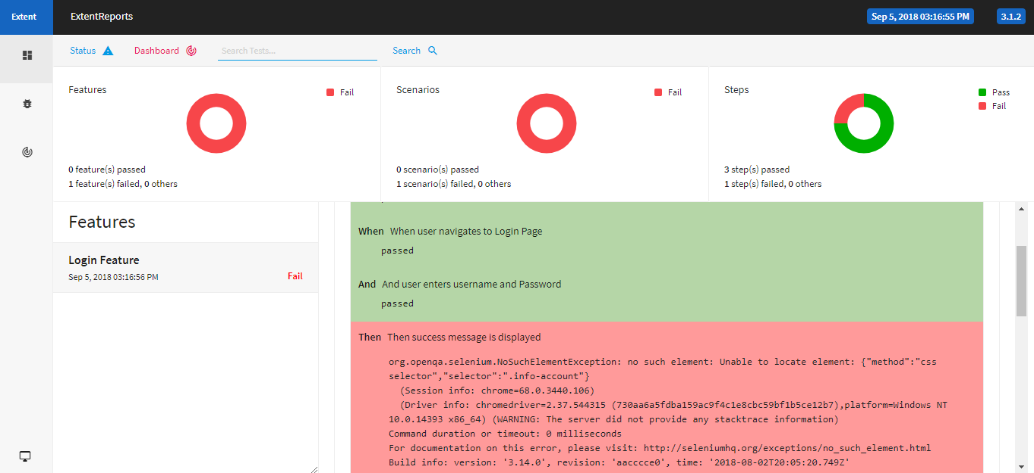

Common Failure Solvation

- If you import Project shown as “ ! “ you have to add jar files if missed .Still it exist you have to download jar manually and add to External jars in Eclipse.
- Compile Error “Path Not found” make sure you have to configure the JRE path in Eclipse
- Feature File not shown as Green font then you need to install the Cucumber plugin and restart the Eclipse.
- Please make sure every time Right click on project →Select Maven →Click on Update project… to avoid Errors.

Thanks

